**Time series Analysis**

A time series is a series of data point indexed in time order. Time series analysis comprises methods for analyzing time series data in order to extract meaningful statistics and other characteristics of the data. Time series forecasting is the use of a model to predict future values based on previously observed values.

**Forecasting Quarterly Car Sales for year 5**

|  |  |  |  |  |  |  |  |  |  |  |  |  |  |  |  |  |
| --- | --- | --- | --- | --- | --- | --- | --- | --- | --- | --- | --- | --- | --- | --- | --- | --- |
| **Sales of cars Yt (1000s)** | 4.8 | 4.1 | 6.0 | 6.5 | 5.8 | 5.2 | 6.8 | 7.4 | 6.0 | 5.6 | 7.5 | 7.8 | 6.3 | 5.9 | 8.0 | 8.4 |
| **Year** | Year one | | | | Year two | | | | Year three | | | | Year four | | | |
| **Quarterly Time (T)** | 1 | 2 | 3 | 4 | 1 | 2 | 3 | 4 | 1 | 2 | 3 | 4 | 1 | 2 | 3 | 4 |

This is quarterly data for car sales .for every year data is recorded in a quarterly basis as shown above.

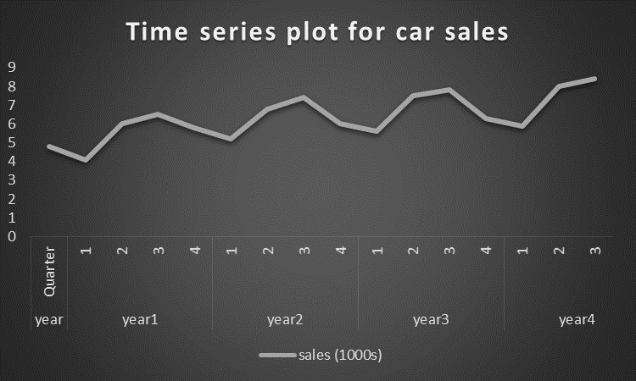

From the above graph you can notice an element of seasonality, it’s noticeable that there’s a cycle repeating itself from one year to the other. Thereby conclude the data follows one of the element of time series data called Seasonal component. There’s also trend component, upward trend of this data. Another component that is always in time series data and not just time series is irregular component. Irregular component is the residual time series after trend cycles and seasonal component.

Classical multiplicative model states Yt =St*It*Tt  whereby;

St - seasonal component

It – irregular component

Tt –trend component

Since the data has irregularities it’s therefore important to smooth the data using moving average(MA) technique of four periods MA(4) and centered moving average CMA(4). All this aim at removing seasonal and irregular components from the data.

Strip off irregular components and remain with seasonal patterns, take an average of quarters in every year i.e average (q1year1+q1of year2+,...,+q1 year4) … of St*It as shown in the table below. After this step the next is to deseasonalize the data to get rid of seasonality and irregularity .The formulae for this,

**Yt/St**

|  |  |  |  |  |  |  |  |  |  |  |  |  |
| --- | --- | --- | --- | --- | --- | --- | --- | --- | --- | --- | --- | --- |
| **Quarterly Data for Cars sales** | | | | | | | | | | |  |  |
|  |  |  | **Yt** | **Smoothing** | **Base line** | **Yt/CMA** |  | **Yt/St** |  | **St*Tt** |
| **t** | **year** | **Quarter** | **sales (1000s)** | **MA(4)** | **CMA(4)** | **St,It** | **St** | **Deseasonalize** | **Tt** | **Forecast** |
| 1 | year1 | 1 | 4.8 |  |  |  | 0.93 | 5.15 | 5.25 | 0.00 |
| 2 |  | 2 | 4.1 |  |  |  | 0.84 | 4.89 | 15.40 | 12.90 |
| 3 |  | 3 | 6.0 | 5.4 | 5.5 | 1.10 | 1.09 | 5.49 | 5.54 | 6.06 |
| 4 |  | 4 | 6.5 | 5.6 | 5.7 | 1.13 | 1.14 | 5.69 | 5.69 | 6.51 |
| 5 | year2 | 1 | 5.8 | 5.9 | 6.0 | 0.97 | 0.93 | 6.24 | 5.84 | 5.43 |
| 6 |  | 2 | 5.2 | 6.1 | 6.2 | 0.84 | 0.84 | 6.19 | 5.99 | 5.03 |
| 7 |  | 3 | 6.8 | 6.3 | 6.3 | 1.08 | 1.09 | 6.24 | 6.14 | 6.69 |
| 8 |  | 4 | 7.4 | 6.4 | 6.4 | 1.16 | 1.14 | 6.49 | 6.28 | 7.16 |
| 9 | year3 | 1 | 6.0 | 6.5 | 6.5 | 0.92 | 0.93 | 6.45 | 6.43 | 5.98 |
| 10 |  | 2 | 5.6 | 6.6 | 6.7 | 0.84 | 0.84 | 6.67 | 6.58 | 5.53 |
| 11 |  | 3 | 7.5 | 6.7 | 6.8 | 1.11 | 1.09 | 6.88 | 6.73 | 7.33 |
| 12 |  | 4 | 7.8 | 6.8 | 6.8 | 1.14 | 1.14 | 6.84 | 6.88 | 7.84 |
| 13 | year4 | 1 | 6.3 | 6.9 | 6.9 | 0.91 | 0.93 | 6.77 | 7.02 | 6.53 |
| 14 |  | 2 | 5.9 | 7.0 | 7.1 | 0.83 | 0.84 | 7.02 | 7.17 | 6.02 |
| 15 |  | 3 | 8.0 | 7.2 |  |  | 1.09 | 7.34 | 7.32 | 7.98 |
| 16 |  | 4 | 8.4 |  |  |  | 1.14 | 7.37 | 7.47 | 8.51 |
| 17 | year5 | 1 |  |  |  |  | 0.93 |  | 7.62 | 7.08 |
| 18 |  | 2 |  |  |  |  | 0.84 |  | 7.76 | 6.52 |
| 19 |  | 3 |  |  |  |  | 1.09 |  | 7.91 | 8.62 |
| 20 |  | 4 |  |  |  |  | 1.14 |  | 8.06 | 9.19 |

Next step is to find out the trend components **Tt,** to do this we run a simple linear regression model. Using the **deseasonalized** data as a Y variable and the **t** as ourXvariable as shown below.

|  |  |  |  |  |  |  |  |  |
| --- | --- | --- | --- | --- | --- | --- | --- | --- |
| SUMMARY OUTPUT | |  |  |  |  |  |  |  |
|  |  |  |  |  |  |  |  |  |
| *Regression Statistics* | |  |  |  |  |  |  |  |
| Multiple R | 0.959451 |  |  |  |  |  |  |  |
| R Square | 0.920546 |  |  |  |  |  |  |  |
| Adjusted R Square | 0.914871 |  |  |  |  |  |  |  |
| Standard Error | 0.21443 |  |  |  |  |  |  |  |
| Observations | 16 |  |  |  |  |  |  |  |
|  |  |  |  |  |  |  |  |  |
| ANOVA |  |  |  |  |  |  |  |  |
|  | *df* | *SS* | *MS* | *F* | *Significance F* |  |  |  |
| Regression | 1 | 7.458103 | 7.458103018 | 162.2026 | 4.34E-09 |  |  |  |
| Residual | 14 | 0.643722 | 0.045980166 |  |  |  |  |  |
| Total | 15 | 8.101825 |  |  |  |  |  |  |
|  |  |  |  |  |  |  |  |  |
|  | *Coefficients* | *Standard Error* | *t Stat* | *P-value* | *Lower 95%* | *Upper 95%* | *Lower 95.0%* | *Upper 95.0%* |
| Intercept | 5.098587 | 0.112448 | 45.34174201 | 1.36E-16 | 4.85741 | 5.339764 | 4.85741 | 5.339763701 |
| t | 0.148107 | 0.011629 | 12.73587889 | 4.34E-09 | 0.123165 | 0.173049 | 0.123165 | 0.17304863 |

Aftergetting the trend components the next thing is to forecast data. Here multiply the **St*Tt** to get forecasted time series data as shown in the above table.

To do this for year 5, drag **t**, **St**, **Tt** and the finally the predicted, value in equal measure of four quarters that is 1,2,3,4.

This is the time series forecast for car sale data up to year 5.

*End*